A Evening with The Misplaced Trilogy Live Band - A StarClinch Presentation
Venue – 201-202, Second Floor, Cyber Hub, DLF Cyber City, Gurgaon, Haryana 122022
Direct Link - http://starclinch.com/the-misplaced-trilogy
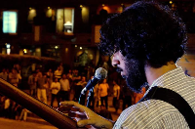
Description - Come and enjoy a European, Mediterranean and American menu as well as Live Band with The Misplaced Trilogy (Full Band) at The Sutra Cyberhub. The Misplaced Trilogy is a setup for avid listeners of English numbers. They cover soulful groovy songs of popular artists such as Coldplay, John Mayer and also make their own acoustic renditions of songs by Avicii and Daft Punk.

