OBJECTIVE
Teaching is a complex, multifaceted activity, often requiring us as instructors to juggle multiple tasks and goals simultaneously and flexibly. This workshop will teach a powerful set of principles that can make teaching both more effective and more efficient, by helping the people to create the conditions that support student learning and minimize the need for revising materials, content, and policies. While implementing these principles it requires a commitment in time and effort.
The teacher understands the central concepts, tools of inquiry, and structures of the discipline(s) they teach and can create learning experiences that make these aspects of subject matter meaningful for students. The teacher understands and uses a variety of instructional strategies to encourage students' development of critical thinking, problem solving, and performance skills. Effective teachers use set induction to put students in a receptive frame of mind that will facilitate learning -- be it physical, emotional, or mental. This workshop will help the people to learn the effective teaching models, implement the techniques in the class room to become a good teacher.

PROGRAMME CONTENTS

- Importance of Effective teaching
- Effectiveness of Teaching and Learning Models vs Traditional Teaching
- Classification of Teaching model
  - Social Model
  - Information Processing Model
  - Personal Model
  - Behavioral Model
- Cooperative Learning Techniques
  - Jigsaw
  - NHT
  - Stad
  - Think pair share
  - Talking chip
- Conceptual Teaching and Learning
- Collaborative Learning Techniques
  - Reciprocal Teaching
  - Think Aloud Pair Problem Solving
  - Group Grid
- Smart Teaching

FACULTY
Sessions will be handled by experienced faculty members from outside and faculty members of Kongu Engineering College.

BOARDING AND LODGING
Accommodation and boarding if required will be provided in the college campus on chargeable basis.

Course fee and Registration

Details | Amount**
Registration Fee  (Including Service Tax) | Rs.575/-

** The registration fee includes course material, lunch and refreshment. Demand Draft for the registration fee must be drawn in favour of “IIP Cell Grant in Aid Account” payable at Perundurai.

HOW TO APPLY

The applicants should send their applications in the specified format through their Principal / Sponsors to reach us on or before 26.02.2016. If selected they should confirm their participation in time.

Scheduled dates

Last date for receipt of Applications: 26.02.2016
Intimation of Selection : 29.02.2016
Confirmation by participants : 02.03.2016

KONGU ENGINEERING COLLEGE
(Autonomous)
PERUNDURAI, ERODE 638052 TAMILNADU

Workshop
On
Effective Teaching and Learning Models – Innovative and Interactive Class room

05.03.2016

APPLICATION FORM

Name :
Designation :
Organization :

Sex :
Age :
Educational Qualification:
Address for
Communication
(with telephone no.
& E-mail ID) :
Experience :
Teaching : _________________________years
Others (Specify) :_________________________years
DD Details :
DD. No. :
Date :
Bank Name :

Need Accommodation: YES/NO

DECLARATION

The above information is true to the best of my knowledge. I agree to abide by the rules and regulations governing the course. If selected, I shall attend the programme for the entire duration. I also undertake the responsibility to inform the Coordinator in case I am unable to attend the course.

Place:
Date: Signature of the Applicant

SPONSORSHIP CERTIFICATE

Mr/Ms/Dr______________________________________________________________________________________is an employee of our Institute / Organization and is hereby sponsored. He/She will be permitted to attend the programme in full, if selected.

Place: Signature of the Sponsoring
Date: Authority
Office Seal

Application form completed in all respects is to be sent to:

Mr.M.Ramalingam,
AssistantProfessor,
Coordinator,
Department of IT,
Kongu Engineering College
Perundurai,
Erode-638 052, Tamilnadu
Mobile: 9994668841, 9003683789
E mail id: mramalingam@kongu.ac.in

ABOUT THE COLLEGE
Kongu Engineering College (KEC) was established in the year 1984. Approved by AICTE, New Delhi and affiliated to Anna University, the institution has been accorded autonomous status from year 2007. The institution has completed 29 years of dedicated and excellent service in the field of technical education. It offers 14 UG programmes, 19 PG programmes and 16 Research programmes and is one among the best self financing Engineering colleges imparting high quality technical education in India. The college is well known for its technical excellence, modern facilities, record of performance with excellent results and enterprising students. The college has got NBA accreditation for all UG programmes, Best Engineering College award, Best Principal award and ISO certification.

ABOUT THE DEPARTMENT
The Department of Information Technology is offering B.Tech. Degree programme in IT, ME Degree Programme in Computer and Communication Engineering and M.Tech(IT) degree programme in Information and Cyber Warfare. The faculty of the department has vast experience in academia and industry. Besides teaching, the department is actively involved in industrial consultancy, and conducting training programmes for students and practicing engineers. The department has implemented the project of “Application of IT for Water Quality Management in water treatment plant” sanctioned by AICTE and “Speech to Text Synthesis in Tamil” sponsored by Tamil Virtual University, Chennai under TSDF scheme. The department has extensive computing facilities with latest software like MATLAB, ORCAD, Visual Studio .Net, IBM-DB2, Websphere Application Server (WAS) etc.,

ABOUT THE LOCATION
The college is situated at Perundurai on the National Highway (NH 47) about 80 km from Coimbatore and 17 km from Erode. It is well connected by air, road and rail.

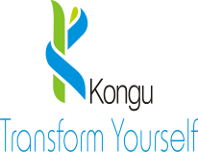

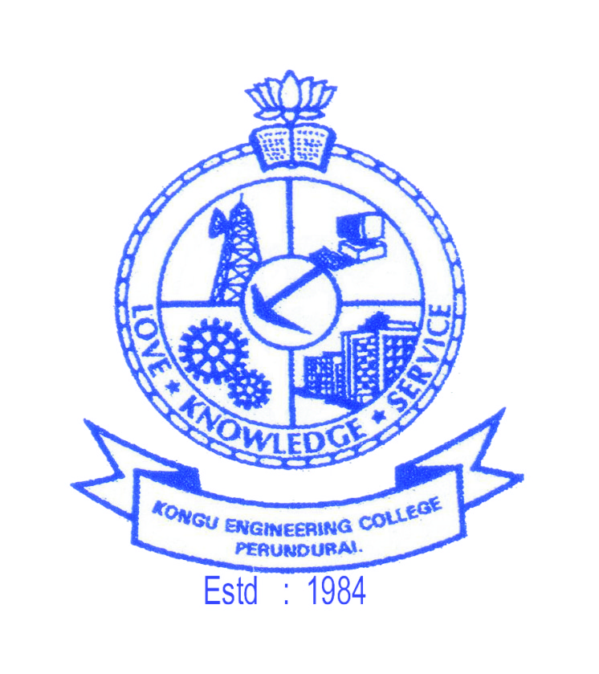
TECHNICAL
ANNOUNCEMENT BROCHURE

Workshop
On

Effective Teaching and Learning Models – Innovative and Interactive Class room

05.03.2016

Convener
Dr.S.Varadhaganapathy
Prof & Head

Coordinators
Mr.M.Ramalingam, AP/IT
Mr.S.Vinothkumar, AP/IT
Mr.A.Jeevanantham, AP/IT

School of Communication and Computer Sciences
Department of Information Technology
&
Industry Institute Partnership Cell
Kongu Engineering College
Perundurai – 638052 Erode Tamilnadu

Tel : 04294 - 226560
Fax : 04294 – 226649
E-mail : mramalingam@kongu.ac.in
Website : www.kongu.ac.in

