**A Woman's Guide to Fertility & Nutrition**

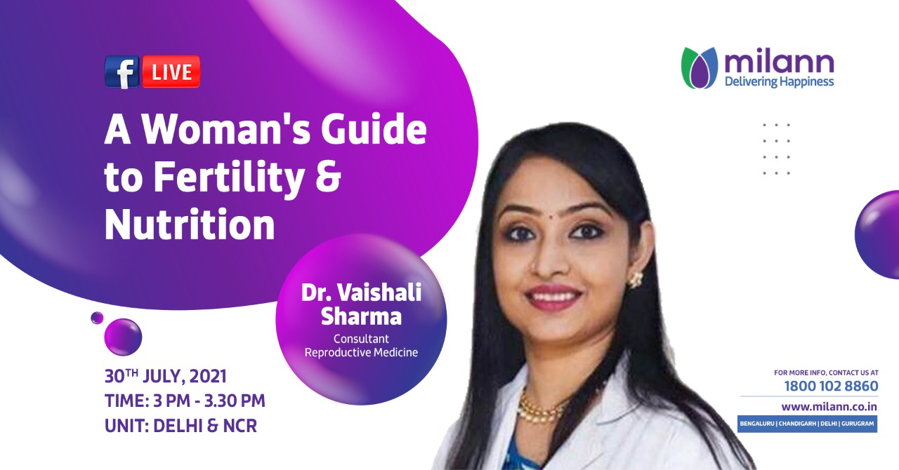

There is no doubt that food and nutrition affect reproductive performance. NCBI reports that an unbalanced diet leads to severe under- or over-weight, which affects ovarian function, increasing infertility. Know more about the effects of nutrition on fertility from Dr. Vaishali Sharma on July 30, 2021, at 3:00 PM. Tune in and ask your questions LIVE on our official Facebook page.

Link to the session: https://fb.me/e/2vWO1HE6p

#DrVaishaliSharma #Parenthood #FertilityTreatment #FertilityAwareness #BestFertilityCenter #FertilityExpert