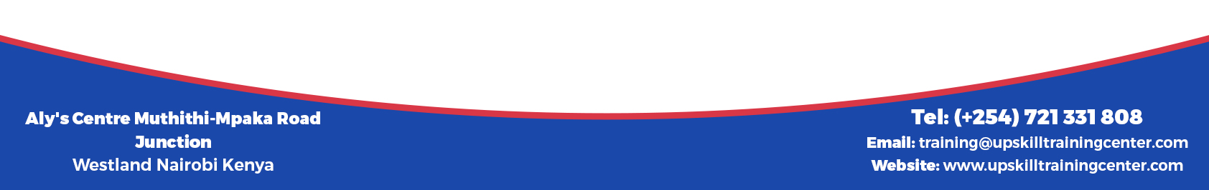

Course title: Result-based Monitoring and Evaluation of Agricultural Projects Course
Course link: https://upskilldevelopment.com/result-based-monitoring-and-evaluation-of-agricultural-projects-course
Introduction
Recently, there has been a realization that agriculture and in particular the viability and sustainability of smallholder farming can be a key to not only improving food security status but also reducing poverty. Monitoring and evaluation helps track agricultural project performance at any given time and provides reasons for an observed project status. In addition, understanding how approaches in Monitoring and Evaluation can be modified or enhanced to optimize positive impact on the intended beneficiaries is important. This five-day course is aimed at providing an overview of results-based monitoring and evaluation methods particularly in agricultural projects.

Duration
10 Days

Course Objectives
- Participants will gain confidence to apply the acquired skills and knowledge to their M&E work
- Participants will be able to share and learn from other country experiences to strengthen their M&E systems in agricultural projects.
- Participants will have an improved understanding of how M&E can improve the quality of their projects while promoting learning and accountability
- Participants will also learn how to be better managers and consumers of evaluations conducted by others

Course Content
Module 1: What is Monitoring and evaluation?
- Why is M&E important
- M&E and the project cycle management
- Step to implementing M&E in a project/programme in agricultural projects
- Type of evaluations
- Methods and tools for M&E
Module 2: Trends towards Result Based M&E
- Managing for Development Results (MfDR)
- MfDR core principles
- MfDR and Result based management (RBM)
- Emergence of RBM and its development
- Seven phases of RBM
- Performance measurement, performance indicators and performance monitoring
- Logical framework and results framework
Module 3:
Introduction to Result Based M&E
- Essential actions to build result based M&E
- Result based M&E cycle
- The power of measuring results
Situation analyses/Needs assessment
- Formative research
- Situation analysis
- Needs assessment
- Tools to conduct a needs assessment
- Illustrative examples of situation analysis and mappings
Module 4:
Designing the M&E system
- The result chain
- Impact path ways
- Logical framework vs Theory of change
- Developing a theory of change
- Components of a theory of change
M&E Frameworks
- Why are M&E frameworks important?
- Considerations when developing an M&E framework
- Results frameworks
- Logical frameworks
Module 5:
Designing indicators and evidence
- What are indicators?
- Characteristics of good indicators
- Process versus result/impact indicators
- Process indicators
- Result indicators
- Output indicators
- Outcome indicators
- Impact indicators
- Developing internationally comparable indicators
M&E Plans
- What does an M&E plan include?
- Important considerations for an M&E plan
- When should M&E be undertaken?
- When monitoring activities should be carried out?
- When should evaluations be conducted?
- Can M&E plans be amended?
Module 6: Evaluation Techniques
- Evaluation questions
- Steps to developing evaluation questions
- Illustrative examples
- Designing evaluations for stakeholder benefit and use
- Choice and use of qualitative and quantitative collection instruments
- Participatory data analysis
- Communicating findings meaningfully for comprehensive stakeholder learning
Module 7: Baseline Assessments
- What is baseline data and how is it collected?
- Needs assessment versus baseline study
- Questions to ask about a baseline plan
- What kind of baseline data is necessary, useful and practical to collect?
- Examples of baseline surveys
Module 8: Data Collection and Analysis
- Quantitative data
- Methods for collecting quantitative data
- Challenges and limitations of quantitative methods
- Qualitative data
- Methods for collecting qualitative data
- Pre/post intervention focus group discussions
- Pre/post intervention interviews
- Illustration and example with selected participatory methods
Module 9: Communicating M&E information
- Developing a communications strategy based on evaluation findings.
- Communicating findings to bring about change.
- Presenting M&E results using different media.
Module 10: Use of M&E Results
- Different uses of M&E results
- To whom to give feedback
- When to give feedback
- How to give feed back
- Embedding learning for personal and organizational benefit
- Becoming change agents for M&E.
- Becoming an M&E champion
Training Approach
This course will be delivered by our skilled trainers who have vast knowledge and experience as expert professionals in the fields. The course is taught in English and through a mix of theory, practical activities, group discussion and case studies. Course manuals and additional training materials will be provided to the participants upon completion of the training.
Tailor-Made Course
This course can also be tailor-made to meet organization requirement. For further inquiries, please contact us on: Email: training@upskilldevelopment.com Tel: +254 721 331 808

