Backlinks data for Freyr energy
Website: https://freyrenergy.com/
Keywords:
Best solar company in Hyderabad
Best solar panel manufacturers in Pune
Best solar panels in vizag
Best solar rooftop in Bhopal
Best solar panel dealers in India
best solar system in delhi
Best solar companies in vizag
list of solar companies in India
solar panel price in India
best solar rooftop Haryana
top solar company in India
best solar companies in Hyderabad

Title:- Best solar company in Hyderabad-freyr
Content:
Freyr Energy is one of best solar company in Hyderabad, Freyr Energy was set up on the principles of making daylight based energy moderate and accessible for everyone. To make determination of sun controlled energy a reality at the grass-root level, we have perceived that customer care, moderateness and receptiveness expect a vital work. With our creative stage, SunPro+, our wide channel-associate association and our viable help we ensure that these three components are directed to guarantee your undertaking into daylight based energy is sans trouble.
Website: https://freyrenergy.com/

Freyr Energy helps make your outing towards accepting sun arranged energy basic and direct. We ensure straightforwardness of information and an issue free experience from pre-arrangement to post-foundation.

We esteem giving basically the best quality daylight based foundations for our customers. Pre-qualified shippers and Freyr ensured installers the country over assurance our close by planetary gathering foundations are energetic, capable and best in quality.

Freyr Energy is one of just a small bunch scarcely any sun based associations with holder India presence offering private daylight based plans. We have helped property holders the nation over seat sun arranged energy and extra gigantic on power charges every month. Our customers have experienced up to 90% decline in their capacity bills after close by planetary gathering foundations.

Logo:

Freyr Energy is one of <a href=”https://freyrenergy.com”>best solar company in Hyderabad</a>, Freyr Energy was set up on the principles of making daylight based energy moderate and accessible for everyone. To make determination of sun controlled energy a reality at the grass-root level, we have perceived that customer care, moderateness and receptiveness expect a vital work. With our creative stage, SunPro+, our wide channel-associate association and our viable help we ensure that these three components are directed to guarantee your undertaking into daylight based energy is sans trouble.

Fre energy is one of the best

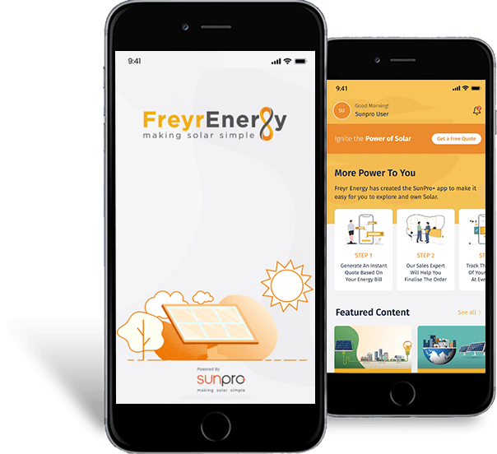
With expert in managing MSMEs and goliath degree experiences across different associations, we can remarkably make the most reasonable sun filled energy plan. Our structures guarantee unsurprising coordination of different fuel sources accessible at your clarification.
All our nearby via planetary social affair establishments go with distant seeing frameworks that help you with following energy age and inspect any issues that may emerge. Our business clients can also profit by sunshine based advances guaranteeing your energy hypothesis underpins adds to a bigger part or a more essential proportion of your EMI.

Freyr Energy is one of best solar company in Hyderabad, Freyr Energy was set up on the standards of making sunshine based energy moderate and open for everybody. To make assurance of sun controlled energy a reality at the grass-root level, we have seen that client care, moderateness and openness anticipate an indispensable work. With our innovative stage, SunPro+, our wide channel-partner affiliation and our feasible assist we with guaranteeing that these three segments are coordinated to ensure your endeavor into sunlight based energy is sans inconvenience.

