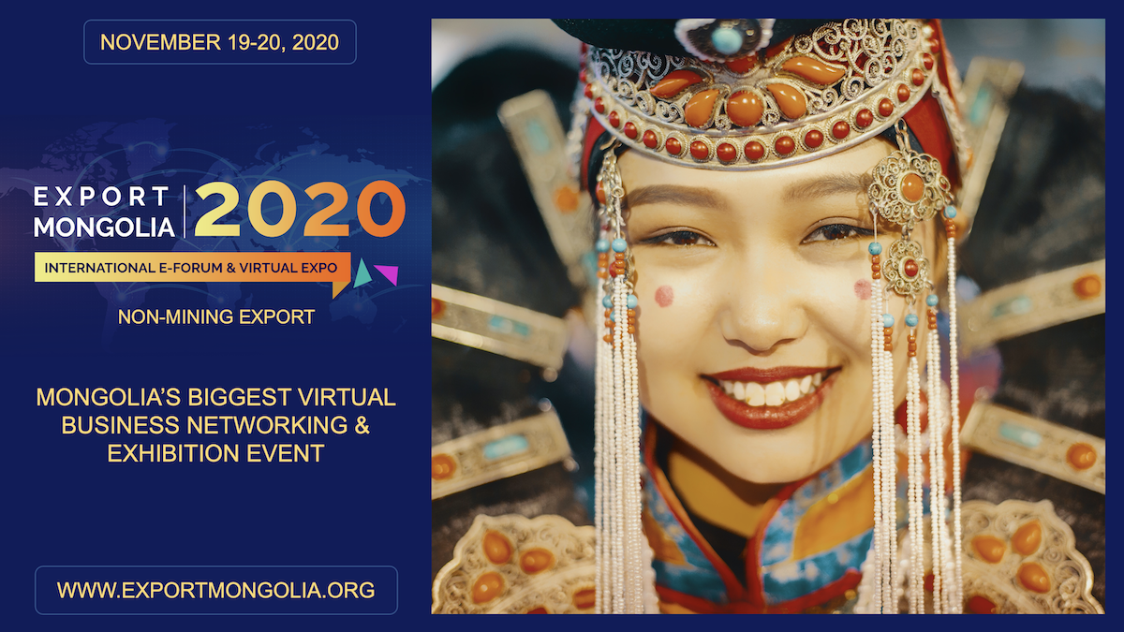

Welcome to join a diverse group of Mongolian and International participants and businesses in B2B and B2G interactive meetings at “EXPORT MONGOLIA 2020” International Virtual Forum and Expo.



A GREAT OPPORTUNITY TO:
- Discover potential Mongolian natural brands and products
- Meet Mongolian entrepreneurs and producers with goods and services for export markets
- Interact with Mongolia’s export and international trade policy decision-makers as well as with Mongolian potential exporters
- Familiarize yourself with Mongolia's investment environment and business opportunities

REGISTER HERE

ORGANIZERS AND SUPPORTERS
