💥Open Call For Retail Tech Startups💥

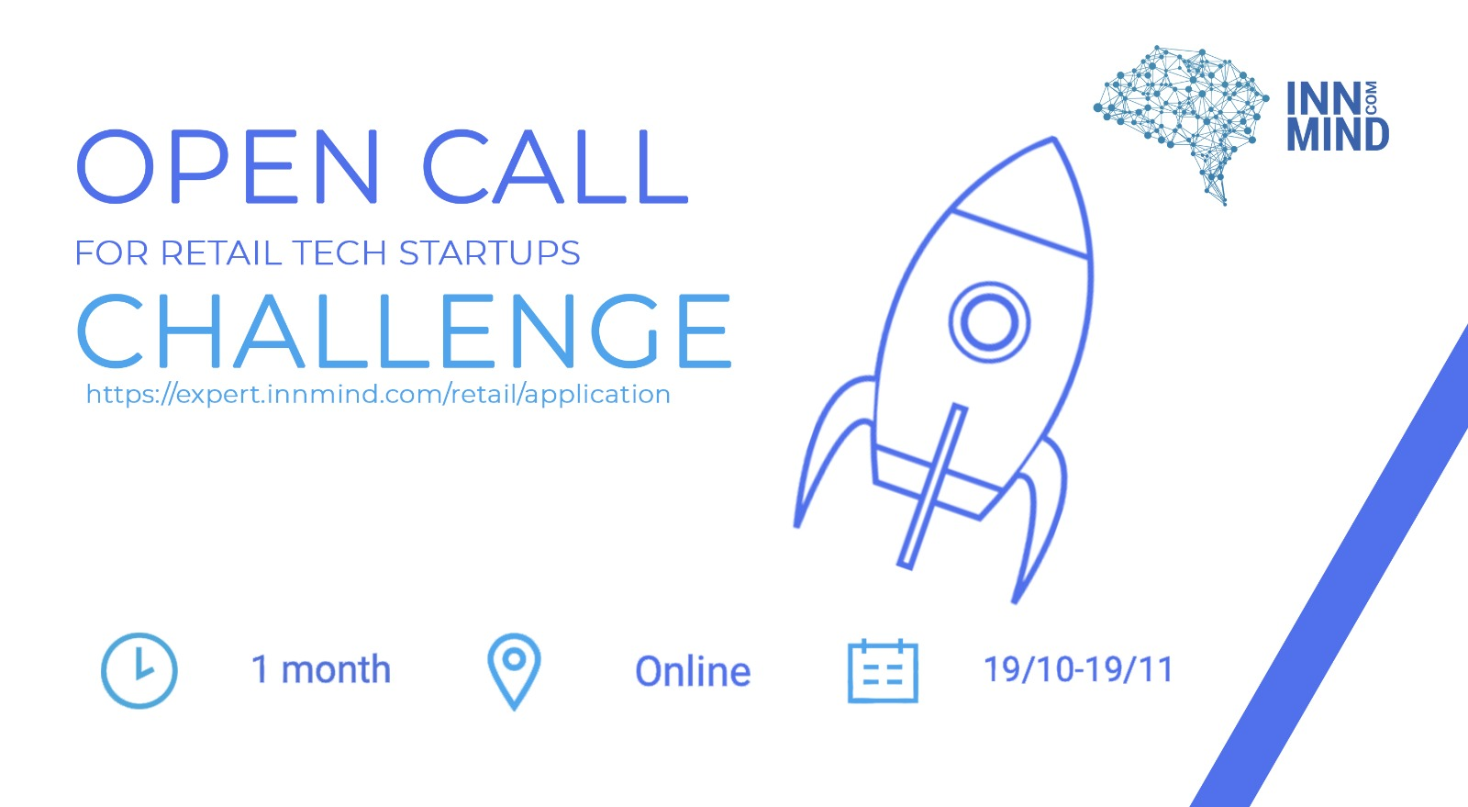
InnMind & Corporate partners launch an open call for breakthrough high-tech SaaS solutions targeting use cases in the retail industry

Based on the requests of a number of international leading CVC engines, InnMind, #1 European digital ecosystem for startups, VCs & CVCs
& Corporate partners launch an open call for SaaS startups targeting use cases in the retail industry.

The main focus is based on (but not limited to) startups that work in the following verticals:
- behavioural science,
- security and theft monitoring,
- quality assurance,
- shelf control management,
- self check-out solutions and others.
B2B startups with a ready to market product or proven track record (from Series A to C) based in Europe, UK, Switzerland and Israel are invited to submit their solution to join an open call! The participation is totally FREE.

⏰ Apply before 12.11.2020
📲 Online
✅ Retail Tech SaaS B2B startups (Series A to C)
📌 Europe, UK, Switzerland & Israel

Get a chance to raise the next funding round and launch industrial pilots with the leading corporate companies!

>>> Apply now <<<

