Godrej Bandra West Pre launch project 8860956846
Godrej Bandra West is a Luxurious Residential Apartments in Bandra, Mumbai. It is the following joint endeavor between Godrej Properties and Omkar Realtors in Mumbai. What can well be named as a significant advancement in the realm of land in the nation, Joint endeavor of two surely understood land manufacturers to build up a 4.25 section of land, ocean confronting property to the home searchers. 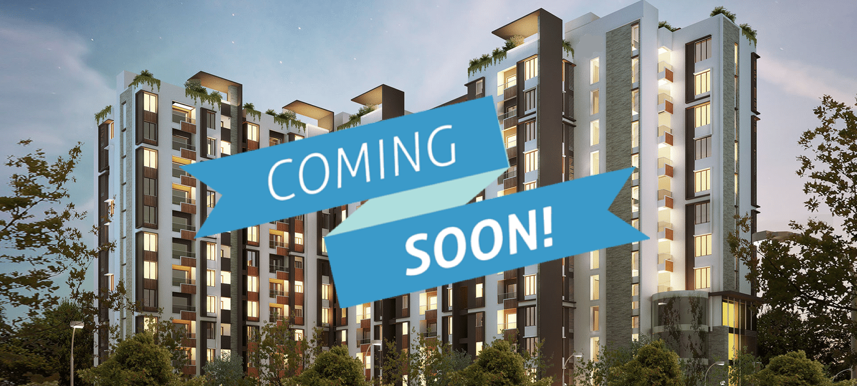
This new pursuit situated in Mumbai covers roughly one lakh million square of saleable territory and will build up an extravagance private pinnacle to offer rich way of life to medium-pay workers. The precise area of this venture is Bandra West, Mumbai which is a requesting area by the greater part of the property searchers. Also, the Highlights of this undertaking is Best availability to all pieces of the city including residential and global airport, Chhatrapati Shivaji is situated inside a separation of 25 minutes, Popular shopping center and market is close by, Best lodgings, eatery and cafeteria lie in the area, Pubs, parlors, banks, and ATM's are situated in the nearby. The way of life of Godrej Bandra west Mumbai will be really tasteful and rich which you can live and encounter by purchasing a condo here. The rapid lifts will be introduced in every single pinnacle of Godrej Project Bandra west Mumbai which will offer you an accommodation of arriving at your floor rapidly. These home in Bandra west Mumbai are structured by world-class modelers with dazzling inside which can pull in anybody. The inside is only remarkable with creator dividers, alluring bogus roof, amazing marble flooring with a measured kitchen and a sharp washroom where every single installation is of high-caliber. You can't get such supreme civilities that Godrej Bandra West Mumbai is offering you. The offices incorporate exercise room, pool, day in and day out force reinforcement, putting out fires frameworks, finished ground, cleared compound and downpour water collecting framework which makes these homes eco-accommodating. Then again, there are numerous games offices for the inhabitants including indoor and outdoor games. In this way, don't be late to obtain such rich homes which is offering you unlimited pleasantries with ultra-level of solace. These homes will increase your living expectations without a doubt

