LEARN TODAY AND LEAD TOMMOROW

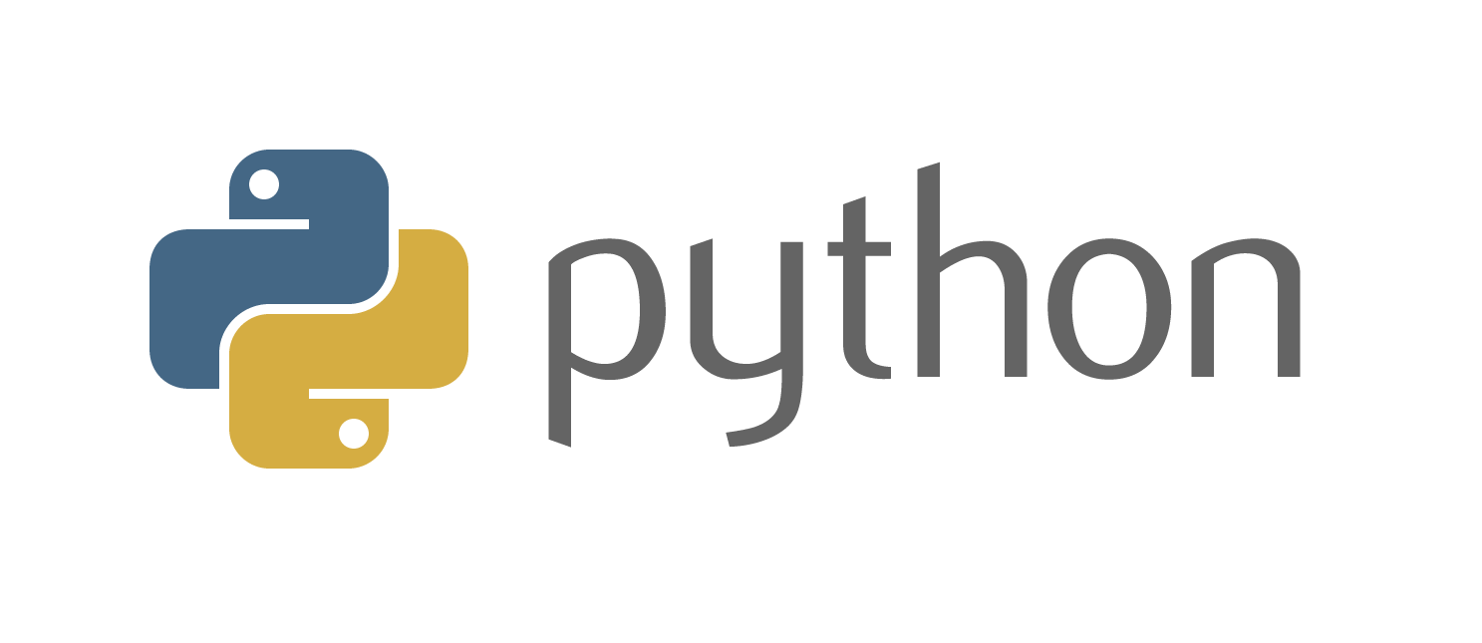
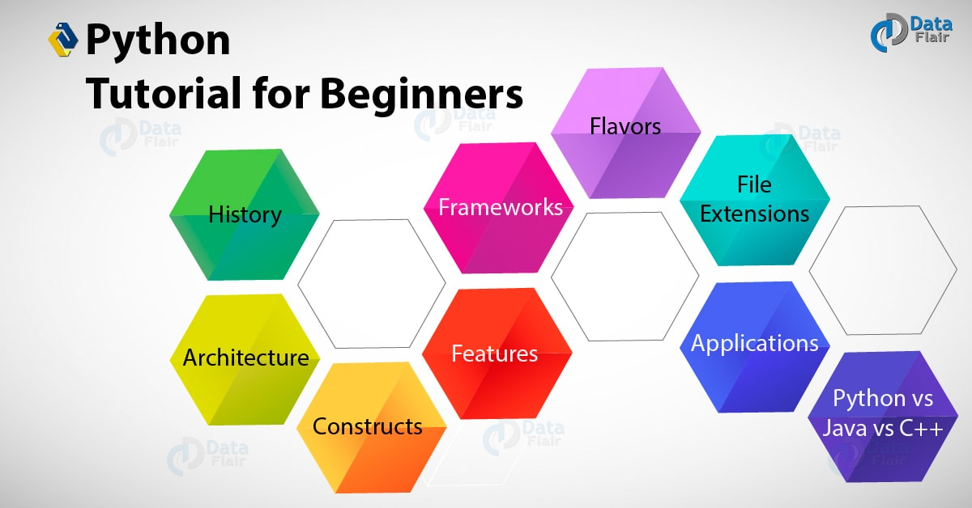

Overview
Let eMexo Technologies Best Python Training in Electronic City, Bangalore take you from the fundamentals of Python to Advance Python Training and make you an expert in developing real time Python applications. Here are the major topics we cover under this Python course Syllabus,Introduction to Python,Beginning Python Basics,Python Program Flow,Functions& Modules,Exceptions Handling,File Handling,Classes In Python,Generators and iterators,Data Structures,Collections,Advanced Concepts – Intro to NumPy and Pandas,Writing GUIs in Python (Tkinter),Python SQL Database Access,Network Programming,Date and Time,Few more topics in-detailed,Regular expression,Threads,Django,Accessing API.Every topic will be covered in mostly practical way with examples.
All the topics will be covered with Practical and hands on training for our Python Course in Electronic City. Our trainers have industry experience with live project experience in cutting edge technologies which they teach. We hire only Best Python industry specialists as trainer for our Python Training in Electronic City.
If you are looking for Python Training in Electronic City eMexo Technologies is the Best Python Training Institute in Electronic City. Come over to our training institute for a free demo class. Let our trainer give you a demo on Python and only then you take the decision to enroll into the training program.
Training Features
Expert Instructors
60 hours of Instructor led Classes. Weekend class:20 sessions of 3 hours each and Weekday class:30 sessions of 2 hours each.
Real life Case Studies
Do a real life case study to understand the usage on real world scenarios.

Assignments
Each class will be followed by practical assignment switch can be completed before the next class.

Unit 1 : An Introduction to Python

What can Python do?

Why Python?

Good to know

Python Syntax compared to other programming languages

Python Install

Unit 2 : Beginning Python Basics

The print statement

Comments

Python Data Structures & Data Types

String Operations in Python

Simple Input & Output

Simple Output Formatting

Operators in python

Unit 3 : Python Program Flow

Indentation

The If statement and its’ related statement

An example with if and it’s related statement

The while loop

The for loop

The range statement

Break &Continue

Assert

Examples for looping

Unit 4 : Functions& Modules

Create your own functions

Functions Parameters

Variable Arguments

Scope of a Function

Function Documentations

Lambda Functions& map

Exercise with functions

Create a Module

Standard Modules

Unit 5 : Exceptions Handling

Errors

Exception handling with try

Handling Multiple Exceptions

Writing your own Exception

Unit 6 : File Handling

File handling Modes

Reading Files

Writing& Appending to Files

Handling File Exceptions

The with statement

Unit 7 : Classes In Python

New Style Classes

Creating Classes

Instance Methods

Inheritance

Polymorphism

Exception Classes & Custom Exceptions

Unit 8 : Generators and iterators

Iterators

Generators

The Functions any and all

With Statement

Data Compression

Unit 9 : Data Structures

List Comprehensions

Nested List Comprehensions

Dictionary Comprehensions

Functions

Default Parameters

Variable Arguments

Specialized Sorts

Unit 10 : Collections

Namedtuple

Deque

ChainMap

Counter

OrderedDict

Defaultdict

UserDict

UserList

UserString

Unit 11 : Advanced Concepts - Intro to NumPy and Pandas

NumPy- Arrays

Operations on arrays

Indexing slicing and iterating

Reading and writing arrays on files

Pandas – Data structure & index operations

Reading and Writing data from Excel/CSV formats into Pandas

Unit 12 : Writing GUIs in Python (Tkinter)

Introduction

Components and Events

An Example GUI

The root Component

Adding a Button

Entry Widgets

Text Widgets

Check buttons

Unit 13 : Python SQL Database Access

Introduction

Installation

DB Connection

Creating DB Table

INSERT, READ, UPDATE, DELETE operations

COMMIT & ROLLBACK operation

Handling Errors

Unit 14 : Network Programming

Introduction

A Daytime Server

Clients and Servers

The Client Program

The Server Program

Unit 15 : Date and Time

Sleep

Program execution time

More methods on date/time

Unit 16 : Few more topics in-detailed

Filter

Map

Reduce

Decorators

Frozen set

Collections

Unit 17 : Regular expression

Split

Working with special characters, date, emails

Quantifiers

Match and find all

Character sequence and substitute

Search method

Unit 18 : Threads

Class and threads
- Multi-threading
- Synchronization
- Treads Life cycle
- Use cases

Unit 19 : Django

Django overview

Creating a project

Apps life cycle

Admin interface

Creating views

URL Mapping

Template system

Models

Form details

Testing

Page redirection

Sending Emails

Deploying Django framework

Generic views

Form processing

File uploading

Cookie handling

Sessions, caching and comments

RSS,AJAX

Unit 20 : Accessing API

Introduction

Facebook Messenger

Openweather

FAQs
1.How is the training organised? How much percentage is theoretical and how much is practical hands on?
We at eMexo believe nothing beats a hands-on practice when it comes to learning a concept. Our teaching methodology is 100% practical hands-on oriented. You learn a concept, you practice it then and there with the trainer. We also give you assignments for each topic which you can practice at home and any doubts regarding the topic can be cleared with the trainer next day.

2.What is the course duration ? How and when do you plan to complete the course ?
We generally cover our courses in 60 hours, however, we are aware that we can’t put a hard- stop to learning with a number. Our trainer will make sure that you have learned everything thatispartofthecurriculum. Thiscould mean 48 hours or 60 hours, doesn’t matter.

3.What is the material provided in the training ?
We have industry standard course material which is used by our trainers to train you. At the end of the training apart from the notes which you have taken during the course, we will also provide you with the training material which was used. This training material includes the training content, interview questions etc.

4.Do you help in preparing for the interview ?
Our trainers are working professionals who work in MNC’s. They are the expert in their domain and they know exactly what an interviewer looks into a candidate. Our expert trainers apart from sharing the interview questions they will also conduct mock interviews to help you prepare for the real interview.

5.Who are your trainers ?
Our trainers are industry experts who work in their respective technologies day in day out. They work in MNC’s and are technology experts within their organisation.

6.What is the total batch size per course?
We maintain a strict batch size of maximum 5 students. We also provide exclusive one to one training as well. Talk to our training partner to get more details.

7.Do you provide certification for the course?
Yes, at the end of training we provide a certification of completion.

8.Will I be joining a new batch or be merged with another batch ?
You will be added to a new batch.

9.Is fast track training available?
Yes, we provide fast-track training as well for those who want to complete the course faster. The curriculum and the total hours required to complete the course will remain same. However, thetrainerwillbespendingmore hours with you to complete the course.

10.Do you assist in job placement ?
Our trainers are expert professionals in their organisations and they often act as the interviewer to hire new candidates. Our trainers will help you prepare your resume with industry standards. After all, they know exactly what to look in a resume.

11.Timings for trainings - Regular training/weekend training
We provide both regular and weekend training. Talk to our training partner to learn more about the timings.

12.Will you be working on a live project during training ?
Yes, apart from doing the hands-on practice our trainer will also be taking a real-world project andworkwithyou for the implementation.

13.What happens if I miss a class?
If you miss a class the content of that class will be taught to you again.With us you might miss a class but not the content.

14.Can I attend a demo before the actual class?
Yes, absolutely! Talk to our training counsellor on phone at 9513216462 or email us at info@emexotechnologies.com to arrange for a free demo. You can also fill in the contact us form below and we will call you to discuss your training requirements.

