Conference name: International Conference on Tissue Repair and Regenerative Medicine
Conference title: Tissue Repair and Regenerative Medicine
Date &Place & Country: November 07-08, 2019 & Melbourne, Australia.
Description of the conference:
Tissue Repair 2019 will be organized with the theme “Promising new directions for Tissue Repair and Regenerative Medicine”. The two-day conference program has been carefully designed to hearten mutual inspiration and fruitful discussions among researchers. The conference will consist of a broad plenary and parallel sessions, in addition workshops, breakout discussion sessions and a poster session.
Tissue Repair 2019 will promote better understanding by the general public about the significance of Tissue Repair, Regenerative medicine in diagnosis, treatment and prevention of diseases.

We invite you to join us at the Tissue Repair 2019, to explore the scientific discussions in this unique platform which is accompanied by the global potential scientists and researchers in the field of Tissue Repair and Regenerative Medicine.

The conference web site: http://tissuerepair.alliedacademies.com/
Address: Sabrina Michelle
Program Director | Tissue Repair 2019
Email: tissuescience@alliedtalk.com
Phone: +44 20 3769 1755
47, Churchfield Road, London, W36AY, UK.

Tissue Repair 2019 (Logo)
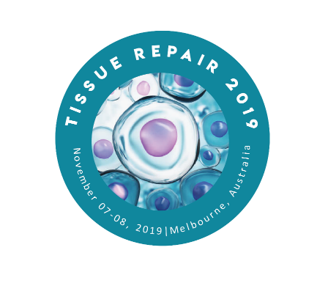
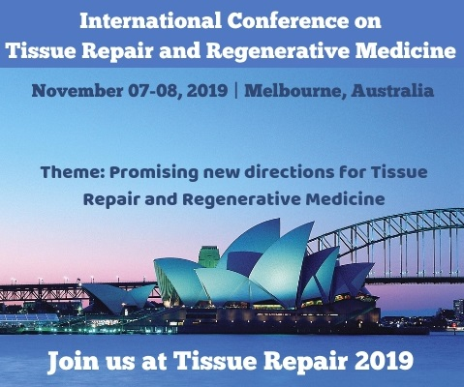
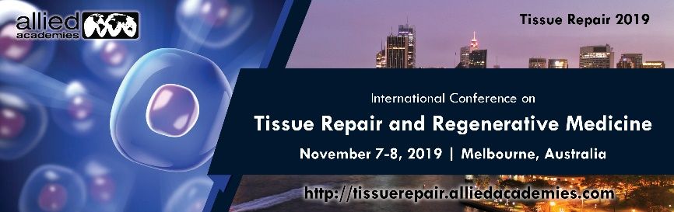

Press Release content

Dear Colleagues and friends,

Allied Academies is delighted to welcome you to Melbourne to take part and share in the International Conference on Tissue Repair and Regenerative Medicine to be held from 07-08 November 2019 in Melbourne, Australia.

Tissue Repair 2019 will be organized with the theme “Promising new directions for Tissue Repair and Regenerative Medicine”. The two-day conference program has been carefully designed to hearten mutual inspiration and fruitful discussions among researchers. The conference will consist of a broad plenary and parallel sessions, in addition workshops, breakout discussion sessions, and a poster session.

Tissue Repair 2019 will promote better understanding by the general public about the significance of Tissue Repair, Regenerative medicine in diagnosis, treatment and prevention of diseases. This conference conduct discussions, share information, meet with present potential researchers and scientists, engage with new Tissue repair and Regenerative medicine experts, Tissue culture and biobanking resources, Development of Stem cell Therapy research, and receive name recognition at this 2-days event.

Global renowned speakers and the most recent developments, techniques, the recent updates in Tissue repair and Regenerative medicine research are the hallmarks of this conference.

We invite you to join us at the Tissue Repair 2019, to enjoy the scientific discussions in this unique platform which is accompanied by the global potential scientists and researchers in the field of Tissue Repair and Regenerative Medicine.

We look forward to seeing you at Melbourne, Australia.

Why to attend the conference?
- To enriching public with new advances in tissue repair and all the related research areas from around the globe.
- This is your unique best chance to outreach the largest research community.
- To execute and exchange the information about the researches done in the labs.
- Attempt to spread research advances
- To extend your research knowledge
- Reinforce your academic reputation
- Explore the new place and the city

Salient Features and Conference Highlights
- Appreciating young researchers by providing young researcher awards
- Collaboration with associations through networks in Tissue Repair meet
- The scientific sessions deal with Promising new directions of Tissue Repair and Regenerative Medicine
- The global platform for networking with experts and businesspeople
- Enlightened and comprehensive conference
- Obtain valuable awareness in the field of Tissue Repair and Regenerative medicine from world experts and skilled researchers

Benefits of attending Tissue Repair 2019

- Accepted abstracts will be published in Journal of Biomedical Research and provided with DOI from CrossRef
- Interacting with experts and professionals from all over the world
- An exclusive opportunity for sponsors, exhibitors and advertisers at this international conference

Who attends?

Tissue Repair 2019 attendees include people working in all aspects of the Tissue Repair and Regenerative Medicine field like: Researchers and academics, Business Delegates, Industries CEO’s and R&D Heads, Members of Associations and Societies, Tissue Researchers, Medical students, Doctors, Plastic surgeons, Global Tissue Repair and Regenerative Medicine Organizations, Associations and Foundations, Tissue Science and Regenerative Medicine Investors, Exhibitors and Sponsors, Biomedicine Researchers, Biotechnologists, Nanotechnologists, Stem Cell Laboratory, Technicians, Biomedical Engineers, Stem Cell Professors, Faculties, Researchers and Students from Academia in the study of Tissue repair, Tissue engineering, Bioengineering, Stem cells and Regenerative Medicine.

Contact person

Sabrina Michelle
Conference Director | Tissue Repair 2019
UK: 47, Churchfield Road, London, W36AY, UK
Phone: +44 203 769 1755
WhatsApp: +44 194 437 0020
Email: tissuescience@alliedtalk.com
Website: http://tissuescience.alliedacademies.com/about

