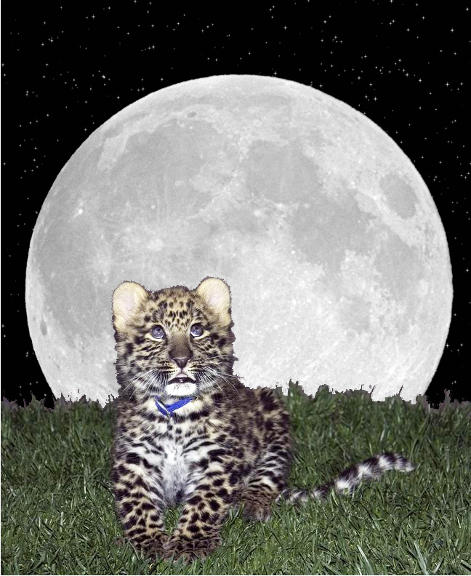
Saturday, June 29 5:30 pm
Enjoy a fun-filled evening with 18 species of wild cats

EFBC’s
Feline Conservation Center special event:
TWILIGHT TOUR
From Bobcats to Tigers, come see your favorite cats! Tour our back lot which is normally closed to the public. Featuring: Bake Sale, Barbeque, Raffle,
and special Cat Enrichment Demonstrations.
Tickets are $20 per person.
All attendees must be at least 18 years old.
Early entry at 5:00 pm if you purchase tickets in advance at www.eventbrite.com (search for “twilight tour”)

For more details visit our website: www.wildcatzoo.org
or call us at: (661) 256-3793 Exit 14 Freeway at Rosamond Blvd

