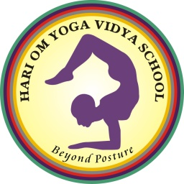

Hari Om Yoga Vidya School

200-Hours Hatha and Ashtanga Vinyasa Yoga teacher education route (YTT) prepared via Hari Om Yoga Vidya college Rishikesh, India with the authorization of Yoga Alliance. This 2 hundred hours Yoga TTC, will widen your expertise inside the religious technological know-how called Yoga. This direction is developed in a specific presentation for a person which might be looking both to begin a profession in yoga or make yoga as an important part of their normal life to gain the general benefits. proper here in Hari Om Yoga Vidya college we've got arranged the steering keeping in thoughts the necessities of all elements under this challenge whether you are a newbie, intermediate or an advanced yoga practitioner. This direction is a globally certified Yoga trainer schooling in Rishikesh on the foothills of the Himalayas, in which you will be skilled about the various divisions of yoga in a traditional and authentic way integrating mind, frame and soul.

