Title: Crystallography of dynamics of metal nanoclusters during chemical reaction at their surface
Scarlett Bary, PhD, DSc, Institute of xxx, Warsaw, POLAND

Abstract: 300 words
In heterogenous catalysis surface structure of metal catalyst may change what modifies surface interactions that in turn affect the structure. The process may generate dynamics of surface that can constitute true origin of chemical activity. One can consider concept of 'active processes' instead of 'active sites'. In our laboratory we have developed in situ powder diffraction technique that is able to register subtle changes of scattered intensities due to modifications of the nanocrystal surface and to interpret these changes via molecular simulations.
Our results allowed quantitative distinction between surface relaxations and reconstructions [1]. The surface reconstruction in response to changing atmosphere appears to be quite common for metal nanocrystals. Sometimes it can lead to cyclic or turbulent phenomena if the reconstruction triggers change in the adsorbate coverage that in turn causes re-reconstruction (or cancels it out) [2]. Gold appears as the metal especially prone to reconstruction. Our results point to gold surface reconstruction occurring on adsorption of many reactive gases. Interpreting precisely peak shape and position we could detect reversible size changes along given crystallographic direction pointing to reversible changes of the nanocrystal shape [3]. Gold surface appears to be mobile enough to quickly increase surface of crystal faces interacting more favorably with the adsorbate. Monitoring oxidation of CO we detected also appearance of a new form of nanocrystalline gold with deep reconstruction of crystal faces leading to a 200 and 220 peak split. The transition may deactivate gold as a catalyst. Precise monitoring of the metal peak position and shape during chemical reaction can provide insight into its structure and dynamics. Degree of the Bragg law violations for various peaks can indicate difference in the interaction with adsorbate on various crystall faces.
Image: 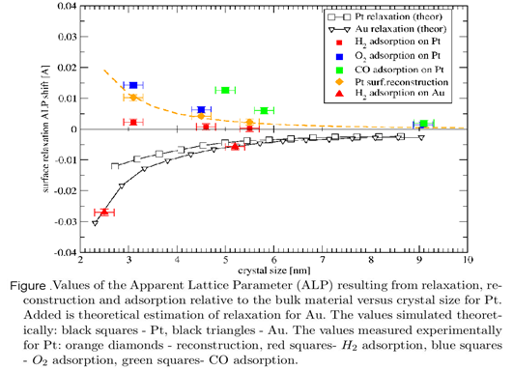

Recent Publications: (Minimum 5)
- Kaszkur Z, Rzeszotarski P, Juszczyk W (2014) Powder Diffraction in studies of nanocrystal surfaces – chemisorption on Pt.
Journal of Applied Crystallography 47:2069-2077.
- Kaszkur Z, Mierzwa B, Juszczyk W, Rzeszotarski P, Łomot D (2014)
Quick low temperature coalescence of Pt nanocrystals on silica exposed to NO- the case of reconstruction driven growth?
RSC Advances, 4 (28): 14758 – 14765.
- Kaszkur Z, Zieliński M, Juszczyk W (2017) The real background and peak asymmetry in diffraction on nanocrystalline matals.
Journal of Applied Crystallography 50:585-593.
- Ilieva L, Petrova P, Pantaleo G, Zanella R, Liotta LF, Georgiev V, Boghosian S, Kaszkur Z, Sobczak JW, Lisowski W, Venezia AM, Tabakova T (2016) Gold catalysts supported on Y-modified ceria for CO-free hydrogen production via PROX.
Applied Catalysis B, Environmental 188: 154-168.
5. Bonarowska M, Kaszkur Z, Słowik G, Ryczkowski J, Karpiński Z (2016) Tetrachloromethane as an effective agent to transform nanoparticles of palladium and gold in supported catalysts. ChemCatChem 8(16):2625-2629.

Biography: (150 words limit)

Scarlett Bary has his expertise in in situ powder diffraction, structural analysis of amorphous and nanocrystalline materials and atomistic simulations. He proposes novel approach to monitor structurally chemical reaction on nanocrystals- the method developed in his lab already for more than decade. As DSc in solid state physics he focuses on physical aspects of chemical phenomena. He is a lecturer of crystallography, member of the state Committee of Crystallography in Polish Academy of Sciences and head of the Department of Catalysis on Metals in the Institute of Physical Chemistry. (orcid.org/0000-0003-4733-4334 )
Email: xxx@xxx

