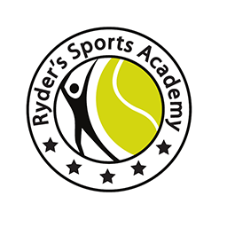
NAME OF THE TOURNAMENT | MEN’S AND WOMEN’S 50K
NAME OF THE STATE ASSOCIATION | HARAYANA TENNIS ASSOCIATION
HONY. SECRETARY OF ASSOCIATION | Mr. SUMAN KAPUR
ADDRESS OF ASSOCIATION | kapursuman@yahoo.com
TOURNAMENT WEEK | 12th MARCH 2018  MATCHES TO BE HELD 10th MARCH & 11th MARCH 2018 (SATURDAY& SUNDAY) – QUALIFYING ROUNDS

THE ENTRY IS TO BE SENT |  | ROHTASH SOLANKI  ALL ENTRY WILL BE ACCEPTED THROUGH EMAIL:- ryders.sports@gmail.com  (NO ENTRIES WILL BE ACCEPTED THROUGH PHONE)
ADDRESS |  | RYDERS SPORTS ACADEMY  DLF PHASE 5, GOLF COURSE ROAD (NEARWESTEND HIGHTS)  GURUGRAM HARYANA.
TELEPHONE |  | FAX
MOBILE NO. | 8744006906,9599944140 | EMAIL | ryders.sports@gmail.com

CATEGORY () | N | ( ) | NS | ( ) | SS | ( ) | CS | ( ) | TS | ( )
AGE GROUPS () | U-12 | ( ) | U-14 | ( ) | U-16 | ( ) | U-18 | ( )
 | Men’s | () |  | Women’s |  | ( )

SIGN-IN |  | QUALIFYING |  | MAIN DRAW
MAIN DRAW SIZE |  | Singles | 32 | Doubles | 16
QUALIFYING DRAW SIZE |  | Singles | Open | Doubles | NA
DATES FOR SINGLES |  | QUALIFYING | 10th &11th MARCH 2018 | MAIN DRAW | 12th MARCH 2018
DATES FOR DOUBLES |  | QUALIFYING |  | MAIN DRAW
ENTRY DEADLINE | 19TH FEB 2018 |  | WITHDRAWAL DEADLINE |  | 5THMARCH 2018

NAME OF THE VENUE |  | RYDERS SPORTS ACADEMY
ADDRESS OF VENUE |  | DLF PHASE 5, GOLF COURSE ROAD (NEARWESTEND HIGHTS)  GURUGRAM HARYANA.
TELEPHONE | 01244308227 | FAX
MOBILE | 8744006906/9599944140 | EMAIL | ryders.sport@gmail.com
COURT SURFACE | CLAY | BALLS | AITA APROOVED
NO. OF COURTS | 6(SIX) | FLOODLIT | YES

TOURNAMENT DIRECTOR |  | Mr. RAJ HAZARIKA
TELEPHONE |  | FAX
MOBILE NO. | 8744006905/9599944140 | EMAIL | ryders.sports@gmail.com

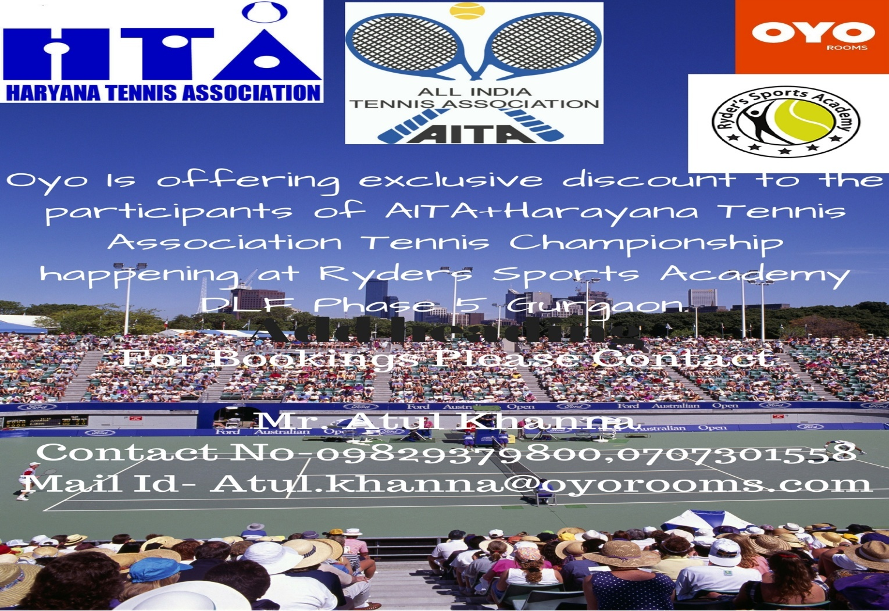

RULES / REGULATIONS
ENTRY | Entry can be sent by post / Fax. No entry will be accepted through telephone.
AGE ELIGIBILITY | Players born:  After 1st Jan 2000 are eligible for participation in U/18,  After 1st Jan 2002 are eligible for participation in U/16,  After 1st Jan 2004 are eligible for participation in U/14,  After 1st Jan 2006 are eligible for participation in U/12.
ENTRY FEE | Total Rs 500/- (FOR SINGLES ONLY )
AITA Registration Card | It is mandatory for the player to carry ORIGINAL REGISTRATION CARD for the sign-in. In case the player registration is in process with AITA, In that case player has to carry Original receipt or copy of mail from AITA confirming that player registration is in process.

All India Tennis Association (AITA), Haryana Tennis Association (HTA) and Ryder's Sports Academy presents a Tennis Tournament at Gurugram, Haryana.

