200 Hour Yoga Teacher Training India Om Yoga Rishikesh
200 Hours Residential Yoga Teacher Training Program offered by Om Yoga Rishikesh is an intensive Yoga TTC course designed to match the requirements of all inspired Yoga aspirants who are willing to plunge deeper and gain in-depth understanding of an ancient technology for well-being known as Yoga.The precisely structured course curriculum of 200 Hours Yoga Teacher Training will allow to immerse yourself deeply in the practice of multiple Yoga styles such as Hatha Yoga, Ashtanga Yoga and Iyengar Yoga as well as all other essential components of the syllabus like Meditation and Pranayama.
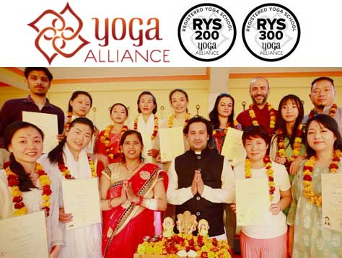
You don't necessarily need to have the desire to become a teacher in order to follow the 200 Hours Yoga TTC program. Our experience has taught us that many people also sign up to deepen their own practice and knowledge about yoga. This program provides an opportunity to all inspired Yoga aspirants to gain in-depth understanding of Yoga and enhance their personal Yoga practices while cultivating and nourishing effective teaching skills which allow them to efficiently share their wisdom with others.
The course curriculum of 200 Hours Yoga Teacher Training is focused on alignment, adjustment and balancing in Yoga postures to encourage participants to do Yoga in proper way. Students will be taught the proper use of props like blocks, blankets, chairs, bolsters etc. Their use will stimulate the effectiveness of the asanas, and increase proper alignment and anatomical awareness,. The use of props also helps to promote healing & recovery from injuries and prevents mis-alignment of the body.

Course Dates for 200 Yoga TTC Program
02 September 2018 to 28 September :: (RYT 200 Hour Certification Courses in Rishikesh, India) Apply Now
02 October 2018 to 28 October 2018 :: (RYT 200 Hour Certification Courses in Rishikesh, India) Apply Now
02 November 2018 to 28 November 2019 :: (RYT 200 Hour Certification Courses in Rishikesh, India) Apply Now

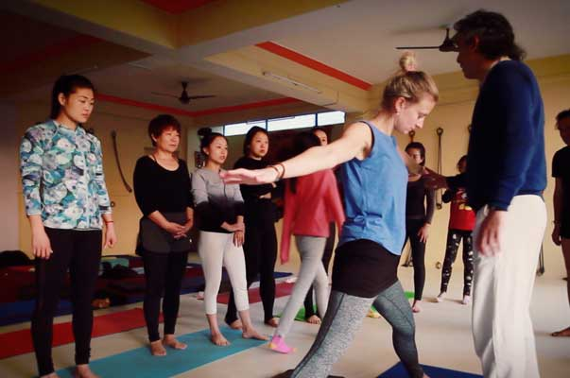
Facebook : https://www.facebook.com/omyogarishikesh//
Twitter : https://twitter.com/omyogarishikesh
google+ : https://plus.google.com/115936716056345831070
Gita Ashram, Near Taxi Stand,
Ramjhula, Swarg Ashram, Rishikesh
Uttarakhand 249304, India
(+91) 9639 721 070
omyogarishikesh@gmail.com
Reserve Now

