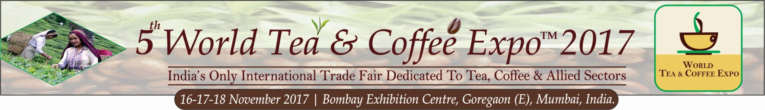

PRESS RELEASE

INTERNATIONAL EXPO ON TEA & COFFEE COMES BACK TO MUMBAI WITH BRAND NEW FEATURES FROM 16TH – 18TH NOV 2017

- The vision of World Tea Coffee Expo Mumbai India is to expand the Indian Beverage business by providing all sourcing requirements under one roof

Growing in size and stature every year, the 5th edition of World Tea Coffee Expo comes back to Mumbai from 16th Nov – 18th Nov 2017 with a host of enhanced features and activities covering the entire gamut of the Hot Beverage sector. Globally recognized at a complete trade show for Tea, Coffee and allied sectors, the three day annual event shall witness about 90+ exhibitors from 8 countries showcasing latest innovative products, machineries, equipment, packaging, technologies, vending solutions, flavours, Retail Chains, certifications, Premixes, government boards etc.

The 5th edition shall have additional features like an upscale Display showcase, wider range of networking events, a special section for e-commerce companies, more educational content and speakers at Conference and interactive workshops – including tasting sessions - by some of the best Baristas/Trainers, Tea Sommeliers and Chefs. 5th World Tea Coffee Expo Mumbai India is supported by Sri Lanka Tea Board and leading associations and chambers from across the world have pledged their support to this important industry initiative.

Since its launch in 2013, the expo has brought global industry players closer, enabled mega deals in addition to being the definite launch pad for new products and technologies especially for start-ups and SMEs who aspire for national / international expansion but have low budgets.

The 2016 edition hosted 67 companies - including Pavilions from Tea Board of India and Sri Lanka Tea Board – which showcased their best to a business visitor base of 3400+ which included senior level decision makers comprising of Retailers, Wholesalers, Distributors, hypermarkets/multi-product retail chains, Tea/Coffee Estate owners, potential franchisees, purchase managers of medium-to-large offices, HoReCa sector professionals many of whom placed large orders with exhibitors. The 2-day hi level conference discussed issues facing the sector and workshops on last day imparted technical skills. Experts from across India were a part of the conference and workshops.

“This niche Expo provides the perfect environment for the hot beverage industry to meet face-to-face and develop real business opportunities. WTCE facilitates participants to strike bulk deals, joint ventures/alliances, franchise deals, appoint marketing agents, knowledge-sharing, meeting government officials and generate large number of business leads.” said Ms Priti Kapadia, Director, Sentinel Exhibitions Asia Pvt. Ltd, the organizers of this unique trade show.

The global market for RTD (Ready-to-Drink) Tea and Coffee is expected to reach $150 billion by 2021 with an annual growth rate of 7%. The Asia-Pacific region is the largest market and also showing maximum growth. The Indian tea and coffee market is one of the largest in world in terms of production, consumption and growth prospects. However, future success depends largely on use of latest technology, seamless upgradation of existing facilities, adapting to ecommerce and cost effective processing – something WTCE strives for. For further information please log onto www.worldteacoffeeexpo.com or call on +912228625132 or email to info@worldteacoffeeexpo.com

From:
| SPR Pvt Ltd | Email: dipika@publicrelationindia.com |

