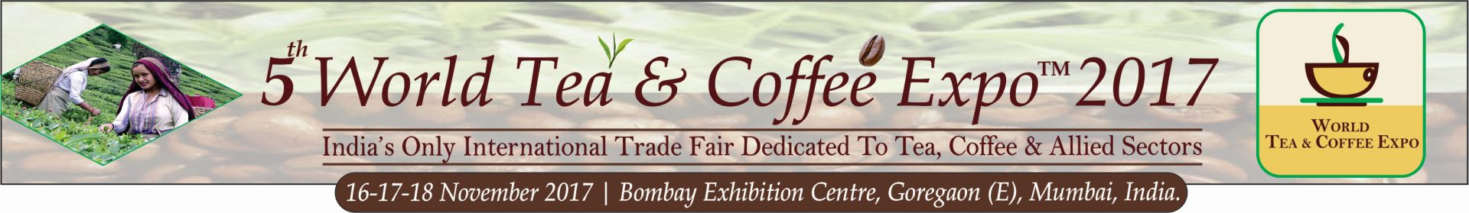

5th World Tea & Coffee Expo™ 2017, Mumbai, INDIA
Thu 16th Nov – Sat 18th Nov 2017

Name of the Show: 5th WORLD TEA & COFFEE EXPO™ 2017, India’s ONLY International Trade Fair focused on the Tea, Coffee & Allied Sectors

Show Dates: 16th -17th - 18th November 2017 (Thu – Fri - Sat) | Website: www.worldteacoffeeexpo.com

Category: Food & Beverages (Particularly Tea & Coffee related Products, Machineries, Innovative Technologies, Vending Solutions, Packaging, Certifications, Boards etc)

Introduction: The “World Tea & Coffee Expo”™ offers India’s only organized and credible avenue for all the stakeholders of the hot beverage sector to come together under a single roof for networking, business expansion and ideas exchange & one to one interaction with high end market players. The Exhibition, High level Conference and Workshops have received rave reviews establishing the expo as the VOICE OF THE INDUSTRY and as the Gateway to Indian markets. For the 2017 edition WTCE is expecting about 100 Exhibitors from 10 countries and a visitor base of 4000+ industry professionals from across India & abroad. Supported by the Ministry of Commerce (Tea Board of India) and Global Associations, the 2017 edition shall have 3-4 country pavilions and International buying delegations from Dubai, Iran, Nepal, Vietnam, Sri Lanka, China, UK to name a few. This expo is the catalyst for companies to expand presence & get branded visibility in India as well as abroad. The show offers huge potential for franchising, marketing alliances, appointing Distributors, bulk orders, joint ventures and overall branding.

Additional Activities : B2B match-making, about 8–10 Workshops (Tea Tasting Sessions, Barista Championships, Latte Art events, Innovative Recipes, Awareness series etc), a Hi-Level 2-day Conference of 18-20 speakers comprising of Industry Stalwarts, academicians and policy makers from India & the world.

Previous Show Results: 2016 total attendance included 67 exhibiting companies from 7 countries and over 3400 Trade Visitors from across India including about 175 from abroad.

Supporters : Tea Board of India, Sri Lanka Tea Board, Global Tea Coffee Association, NETA, Packaging Industry Association Of India (PIAI), Small & Medium Business Development Chamber Of India (SME Chamber of India), The Bombay Tea Traders Association (BTTA), Federation of Indian Tea Traders Association (FAITTA), Confederation of Indian Small Tea Growers Association (CISTA), Darjeeling Tea Association, Specialty of Coffee Association of Europe, Association of USA Inc., ADEMA The Tea Association of Italy, African Fine Coffees Association.

Exhibitor Profile: Tea & Coffee Manufacturers & Brands, Machinery Manufacturers & Packaging companies. Tea Gardens & Coffee Estates, Dealers/Exporters/Importers, Vending Machines Manufacturers, Roasters And Blenders, Flavoured / Instant Beverage Manufacturers, Manufacturers of Equipment & Appliances, Raw Materials Suppliers & Manufacturers, Display of Herbal / Green / Slimming etc teas, Fine Chocolate & Gourmet Mint Manufacturers, Processors & Processing machinery Manufacturers, Milk & Milk Products, Sugar & Sugar substitutes/Artificial Sweeteners, Spices Manufacturers, Beverage accessories manufacturers, Biscuit, Confectioneries Manufacturers, Chain Stores, Super stores, Fitness equipment, Retail Café chains / Franchisors, Airlines, Service Providers & Others.

Attendees / Visitors Profile : Tea & Coffee Distributors Retailers & Wholesalers, Hoteliers/ Institutional Caterers, Restaurateurs & Cafe owners / Resorts / Caterers, Airlines, Importers & Exporters, International delegates & Buying Teams, Dealer, Trade Buyers, Hotel Suppliers Dealers, Mass Grocers, Supermarkets & Malls, Purchase Managers of large offices & retail chain, Packaging professionals, F & B / Catering Managers, Dieticians / Nutritionists / Food Professionals, Chef’s & cooking Experts, Tea & Coffee Aficionados, Govt. Officials / Brokers, Health & Fitness conscious Visitors, General & Others Visitors.

Expo Location: Bombay Exhibition Centre (NSE), Goregaon East, Mumbai, INDIA (Mumbai is the commercial capital of India and a centre which attracts serious buyers from all parts of the country and the globe.)

Registration and Admission: Entry is free. The show is not open to general public. This is a trade event and only industry professionals will be allowed. No one under 18 permitted.

Show Contact: Mr. Mitesh M Kapadia, Project Director on +91 9820503876 mitesh@sentinelexhibitionsasia.com; Tel: +91 22 28625131

Show Owner and Producer: Sentinel Exhibitions Asia P Ltd (www.sentinelexhibitionsasia.com)

Expo Logo:
